Professional Behavior

1. Interacting Professionally with the instructor –

Throughout the semester I kept in touch with the instructor as much as I needed to. I have asked him many questions and always received a response very quickly. Here are a few examples of my interactions with the instructor.

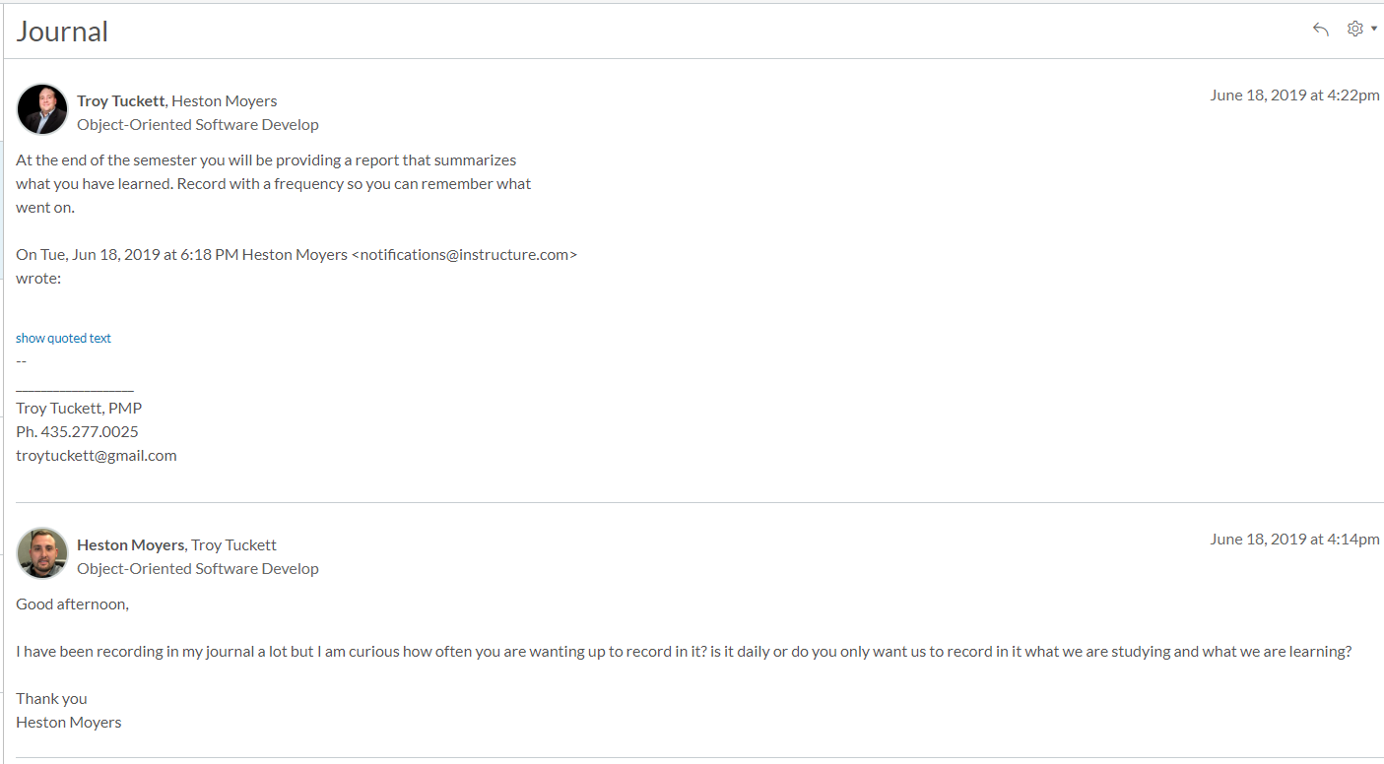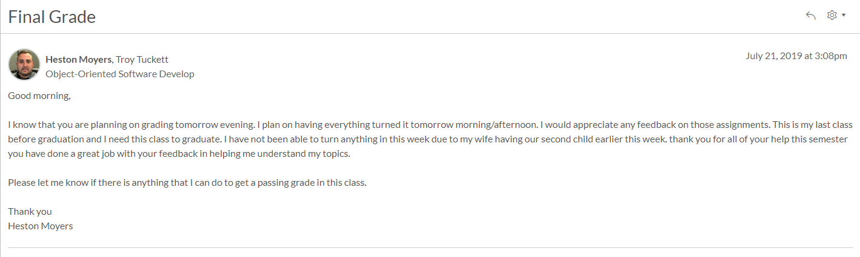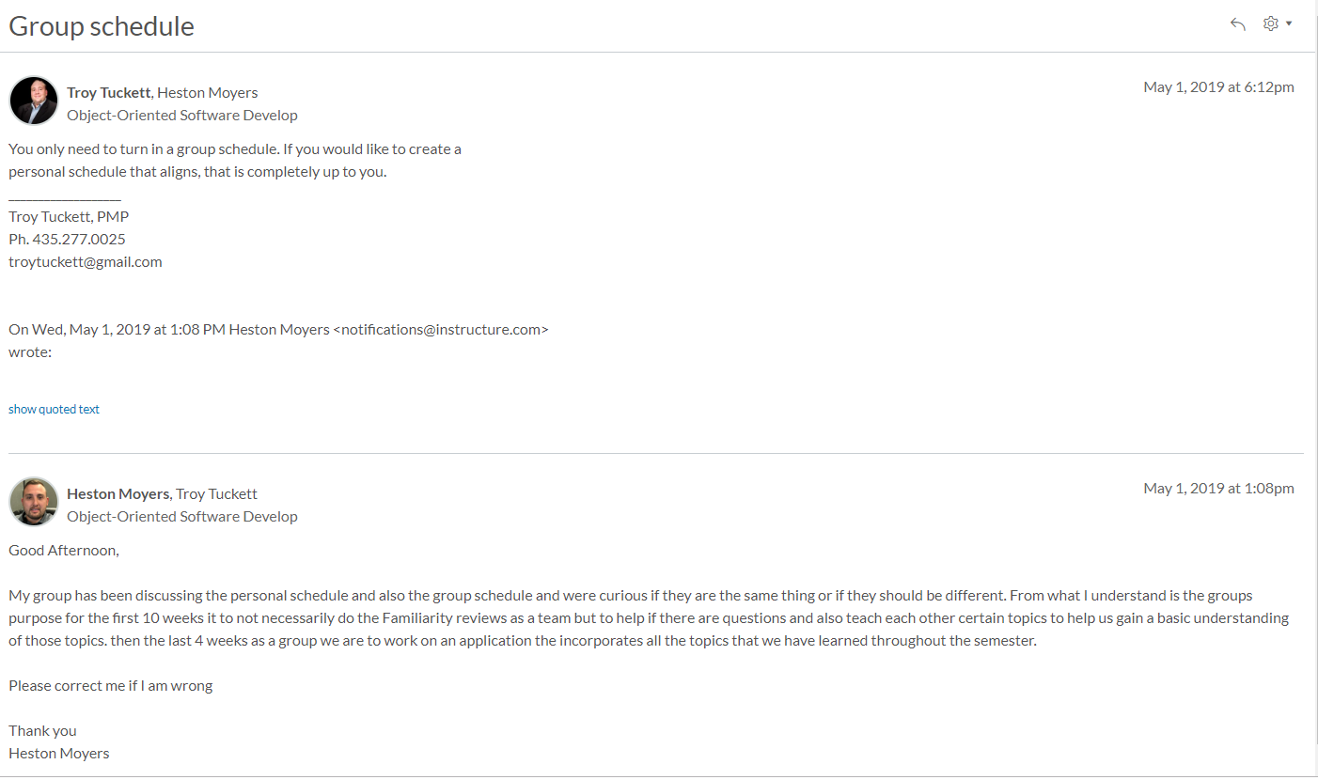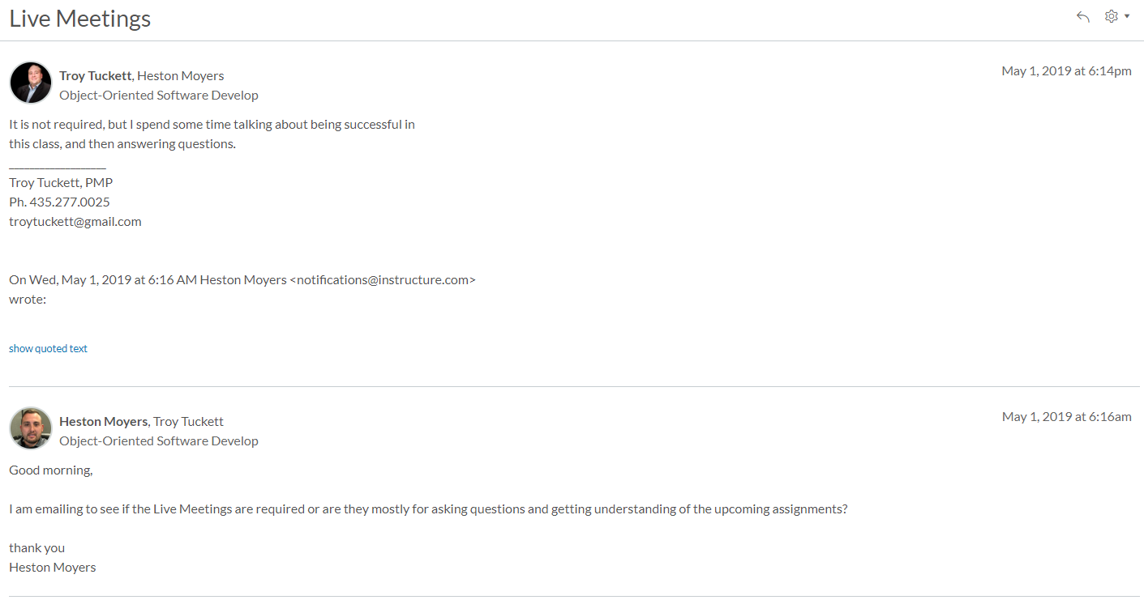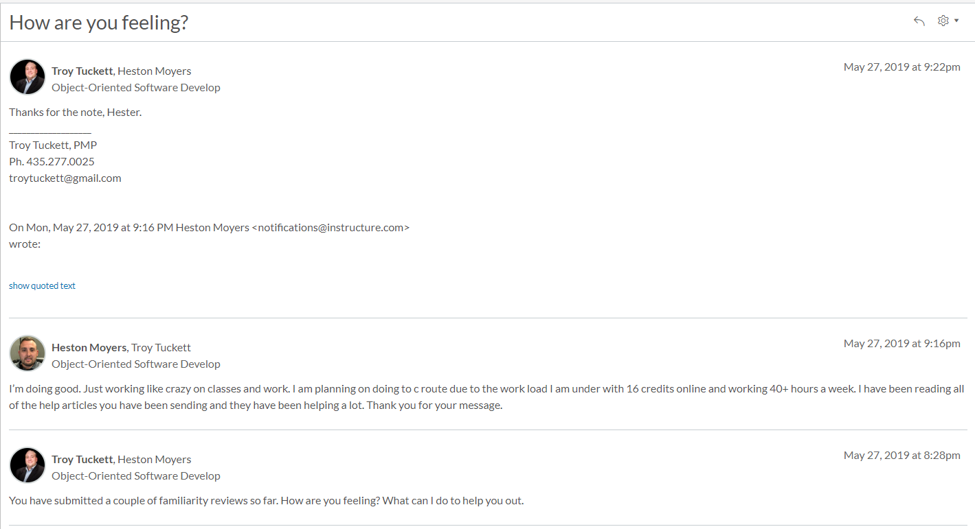

I have learned a lot about Bro. Tuckett during this semester. He is very helpful and provides great help when asked but he is not a mind reader. He can’t help you until you ask for the help. I am good at asking questions and getting the help that I need. Communication is so important to any success as a student, father and spouse. I just had my second child on Monday, and it has been interesting to learn how to communicate with my daughter even though all she can do is cry.

1. Interacting Helpfully and Professionally with Other Teams

Teamwork in this class is important. Being part of a team was amazing and I received a lot of help from my own teammates. I also had the opportunity to help other members of other teams with their questions and concerns. Here are a few examples of the interactions that I have had with other teams and how I helped them answer questions that they had. Not only answering their technical questions but getting to know the other teams through spiritual thoughts and personal experiences.

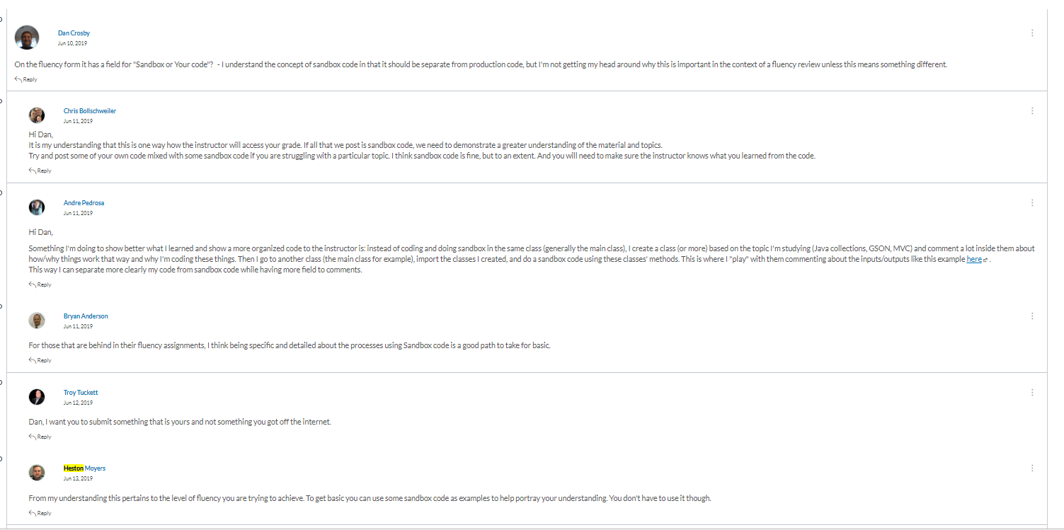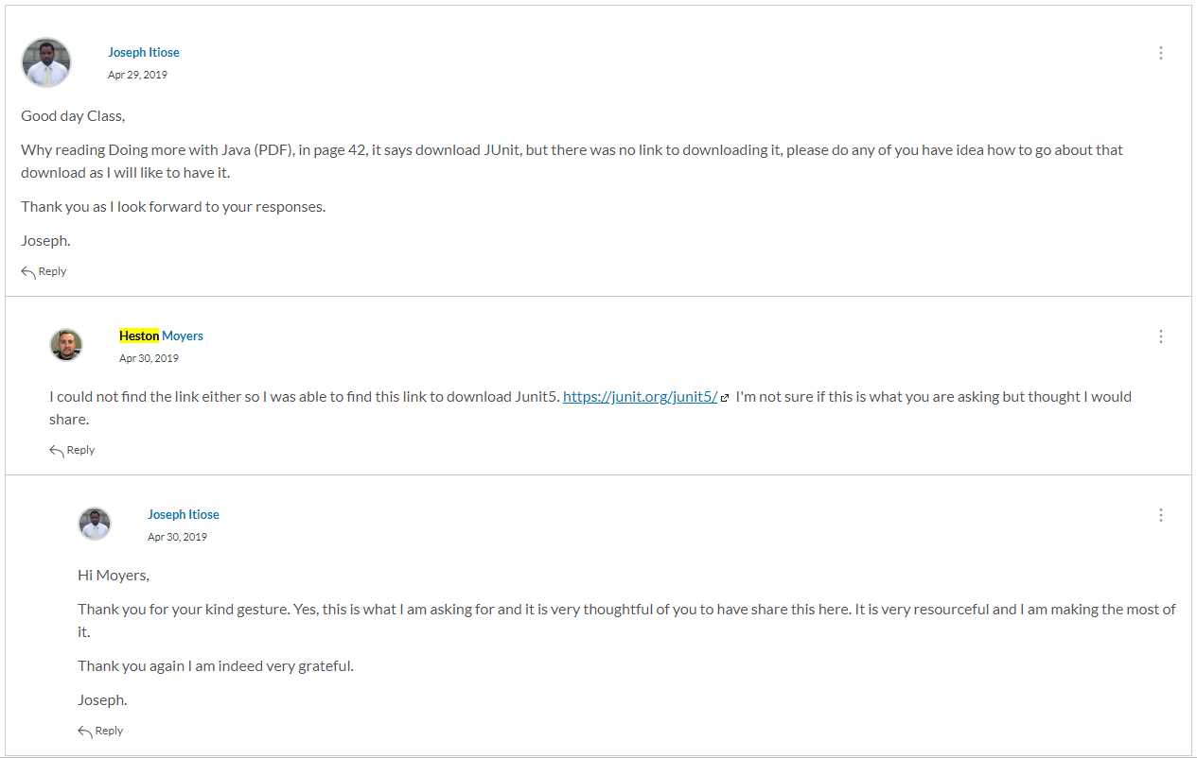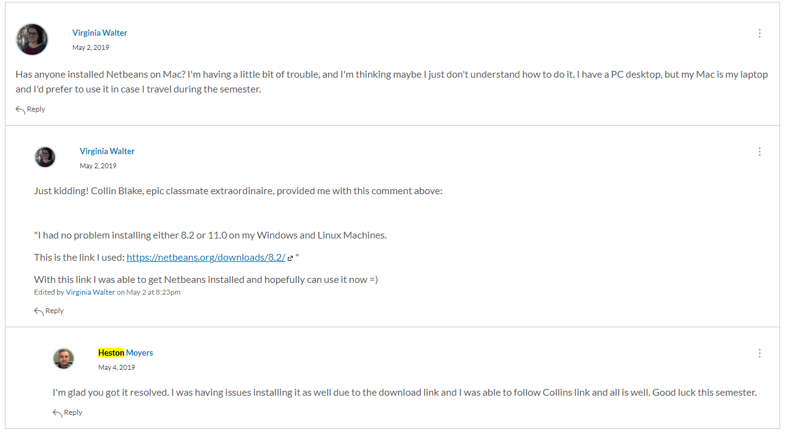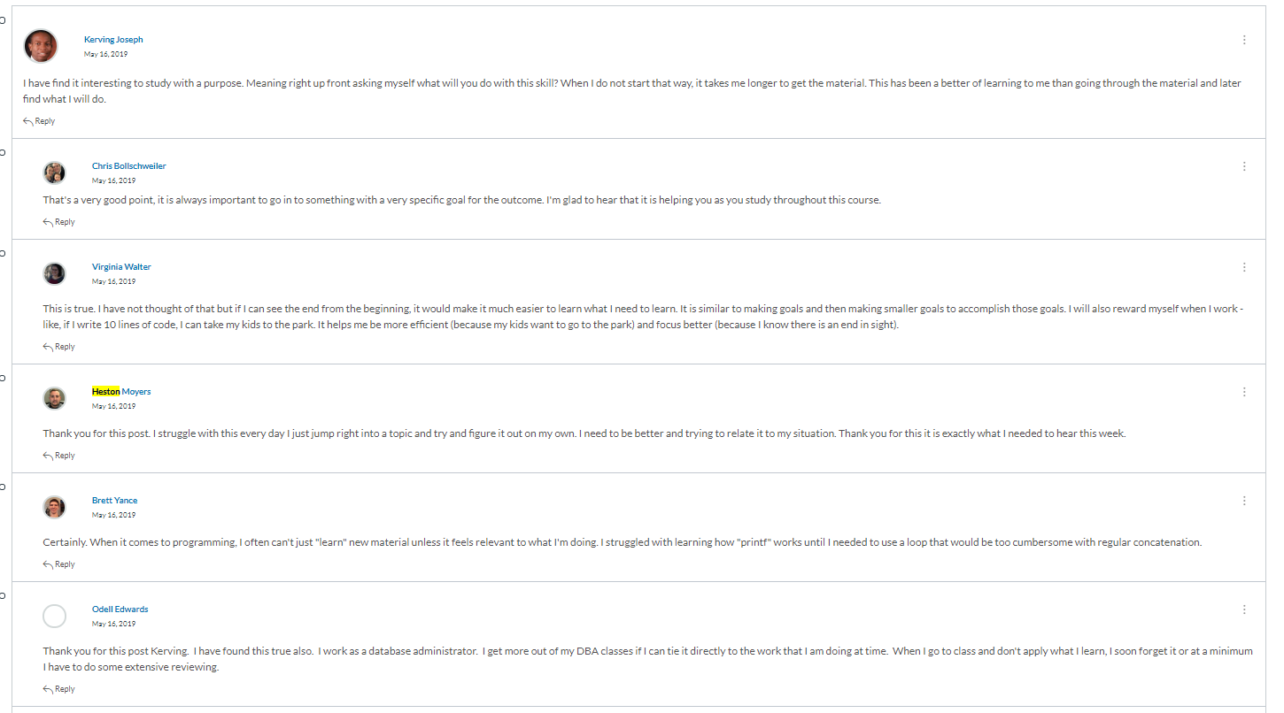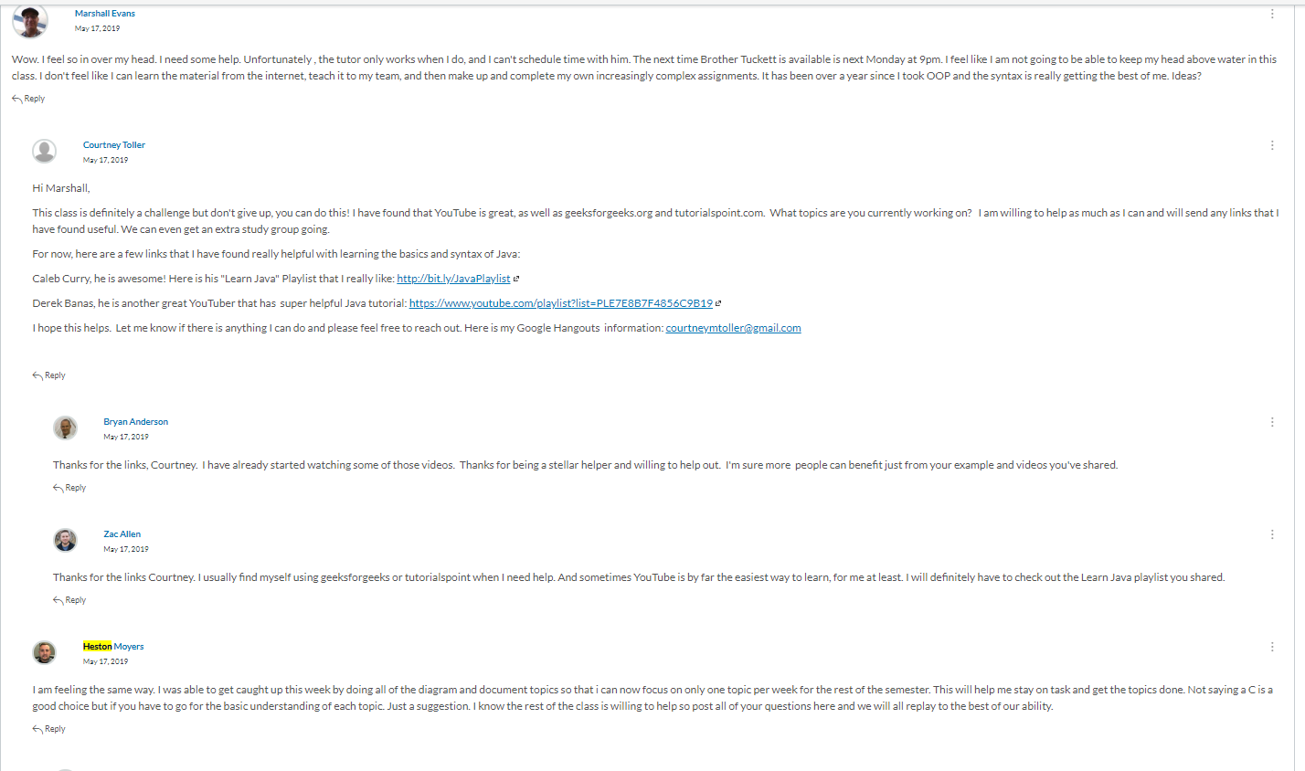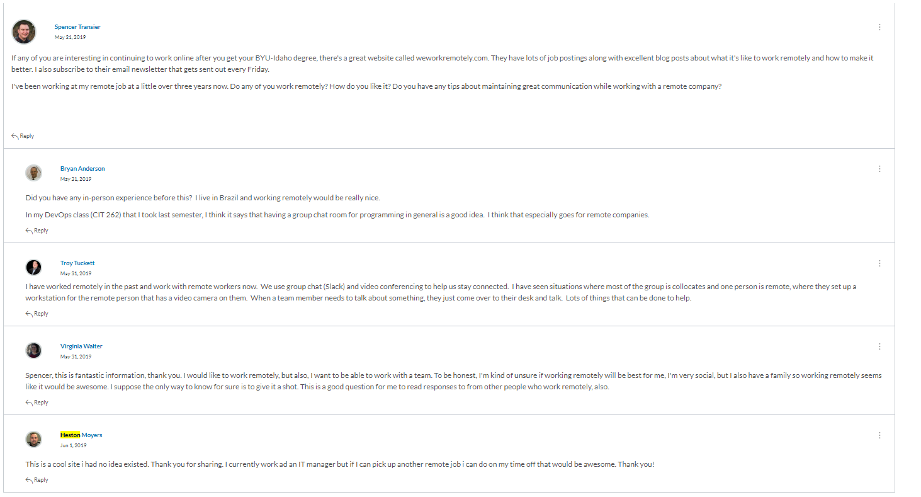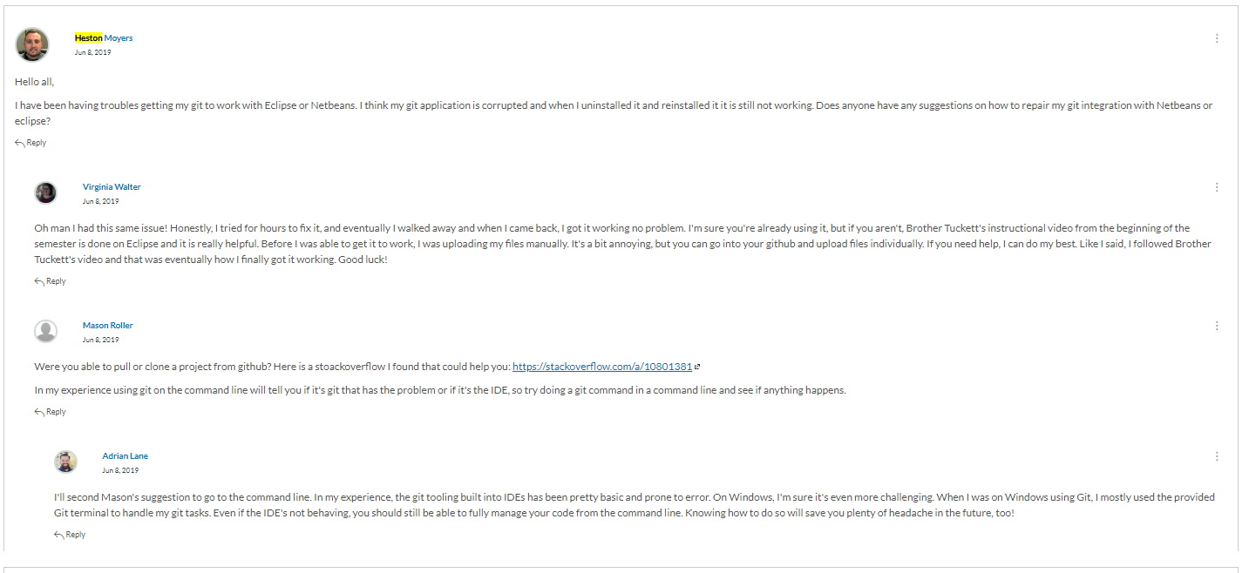

The developer forum was designed to help us interact with other teams and ask questions for other team members help. I have taken this seriously and strived to get everything I could out of this discussion. I also tried to post on sites like stack overflow and things like that so that I could help others in the community. Here is an example of one of my responses. 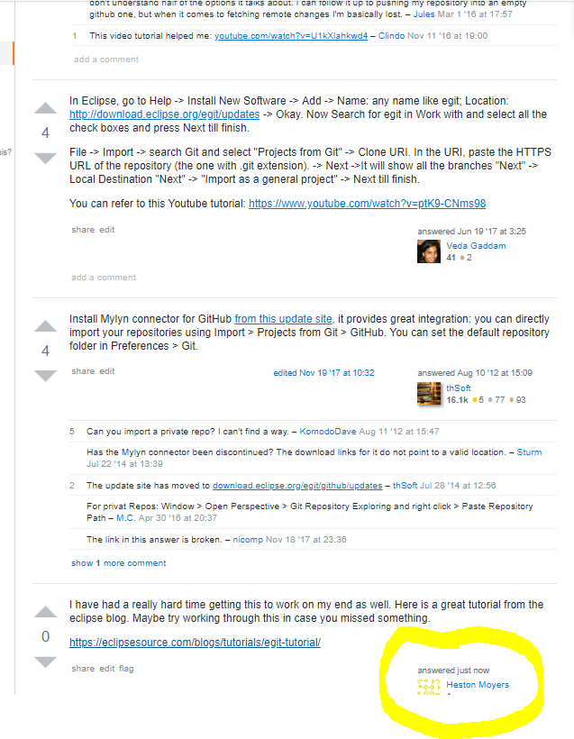

1. Supporting the Team by Teaching, etc.

This semester each of us as group members were in charge of teaching a few of the topics to each other. I was in charge of teaching the topics

1. MVC

Here is my teaching presentation for this topic.

MVC – <https://byui.zoom.us/recording/share/OjwegjFw6q1K-YpMtqlzgLPh9VJRESGJUQyLzloxhkGwIumekTziMw>

1. Self-Reflection/Meta-Cognition:

Several times during this semester I had Meta-cognition. On Monday of each week in my weekly journal I would come up with questions that I wanted answered throughout the week as I studies. Along with my studies of the topics for that week I would try to have 1 question that I wanted answered that would create meta-cognitive thoughts so that I could think about thinking. In week 4 I had a great experience. I know that I am really bad at studying. I have a hard time just reading and understand what is being explained in the text. I wanted the question answered How can I engage my mind to have a desire to learn and want to understand what I am reading. So, during that week I was researching learning techniques on how to learn and I thought to myself why does my mind have that much control over my learning? I should be able to read and tell my brain that I want to learn and understand what I’m going to study.

Another way that I have implemented meta cognition is to ask myself the question “How would I have taught this subject?” As a group we have been assigned to teach specific topics from the 14 topics that we are in charge of learning this semester. For an example of this I was able to see mason present the topic of Junit. He created a power point that has a couple slides with some information about Junit. He explained briefly what Junit was and provided a small sample code that briefly explained the process of testing with Junit. After that presentation I asked myself. Would I have done anything different in presenting this topic. I think I would have provided a little more detail of the importance of Junit and how it helps with a testing development process. I also would have physically run a test so that it would show what the test looks like in action.

1. Teams Agile Methodology:

Throughout this semester my team has participated in a SCRUM Agile method by implementing a daily standup meeting through Standup-Allice Along with this we Held a weekly Meeting to Go over our previous week and what we can do better as a group in the future. Here are a few examples of our daily standups. 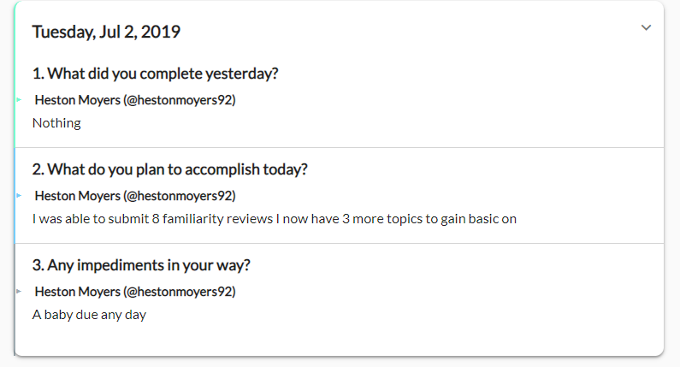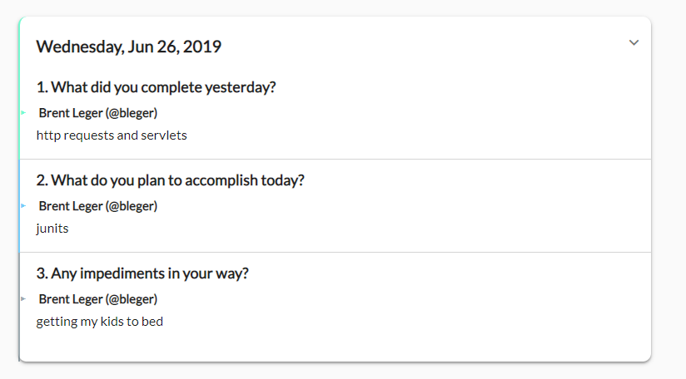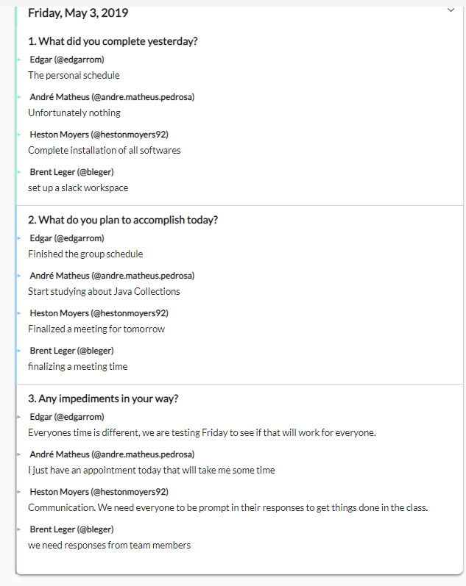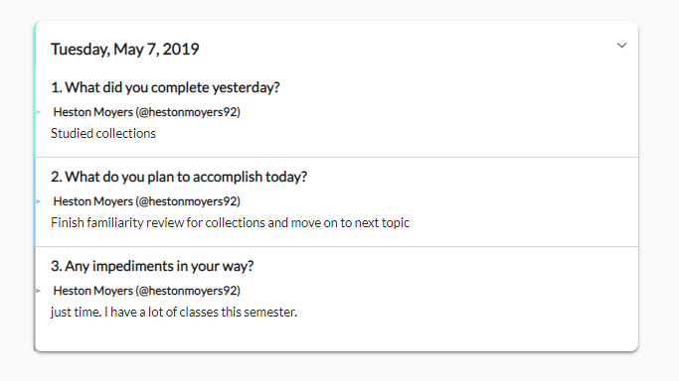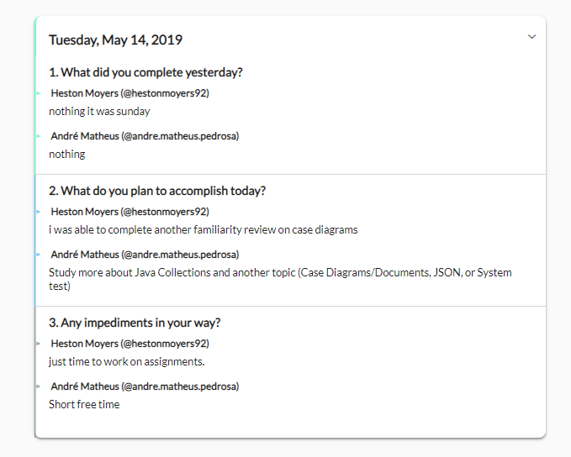

I didn’t include all of them because that would have been a lot to read through. This agile method really helped me stay on track and keep in constant communication with my group. By doing this I was able to see where I was at according to the group schedule as well as everyone else. I think this helped all of us understand how to help each other out with the topics and anything else in our lives. As we met for the last time as a group last Friday I felt like we had accomplished so much as a group. and owe all of my progress in the class to them as a group.